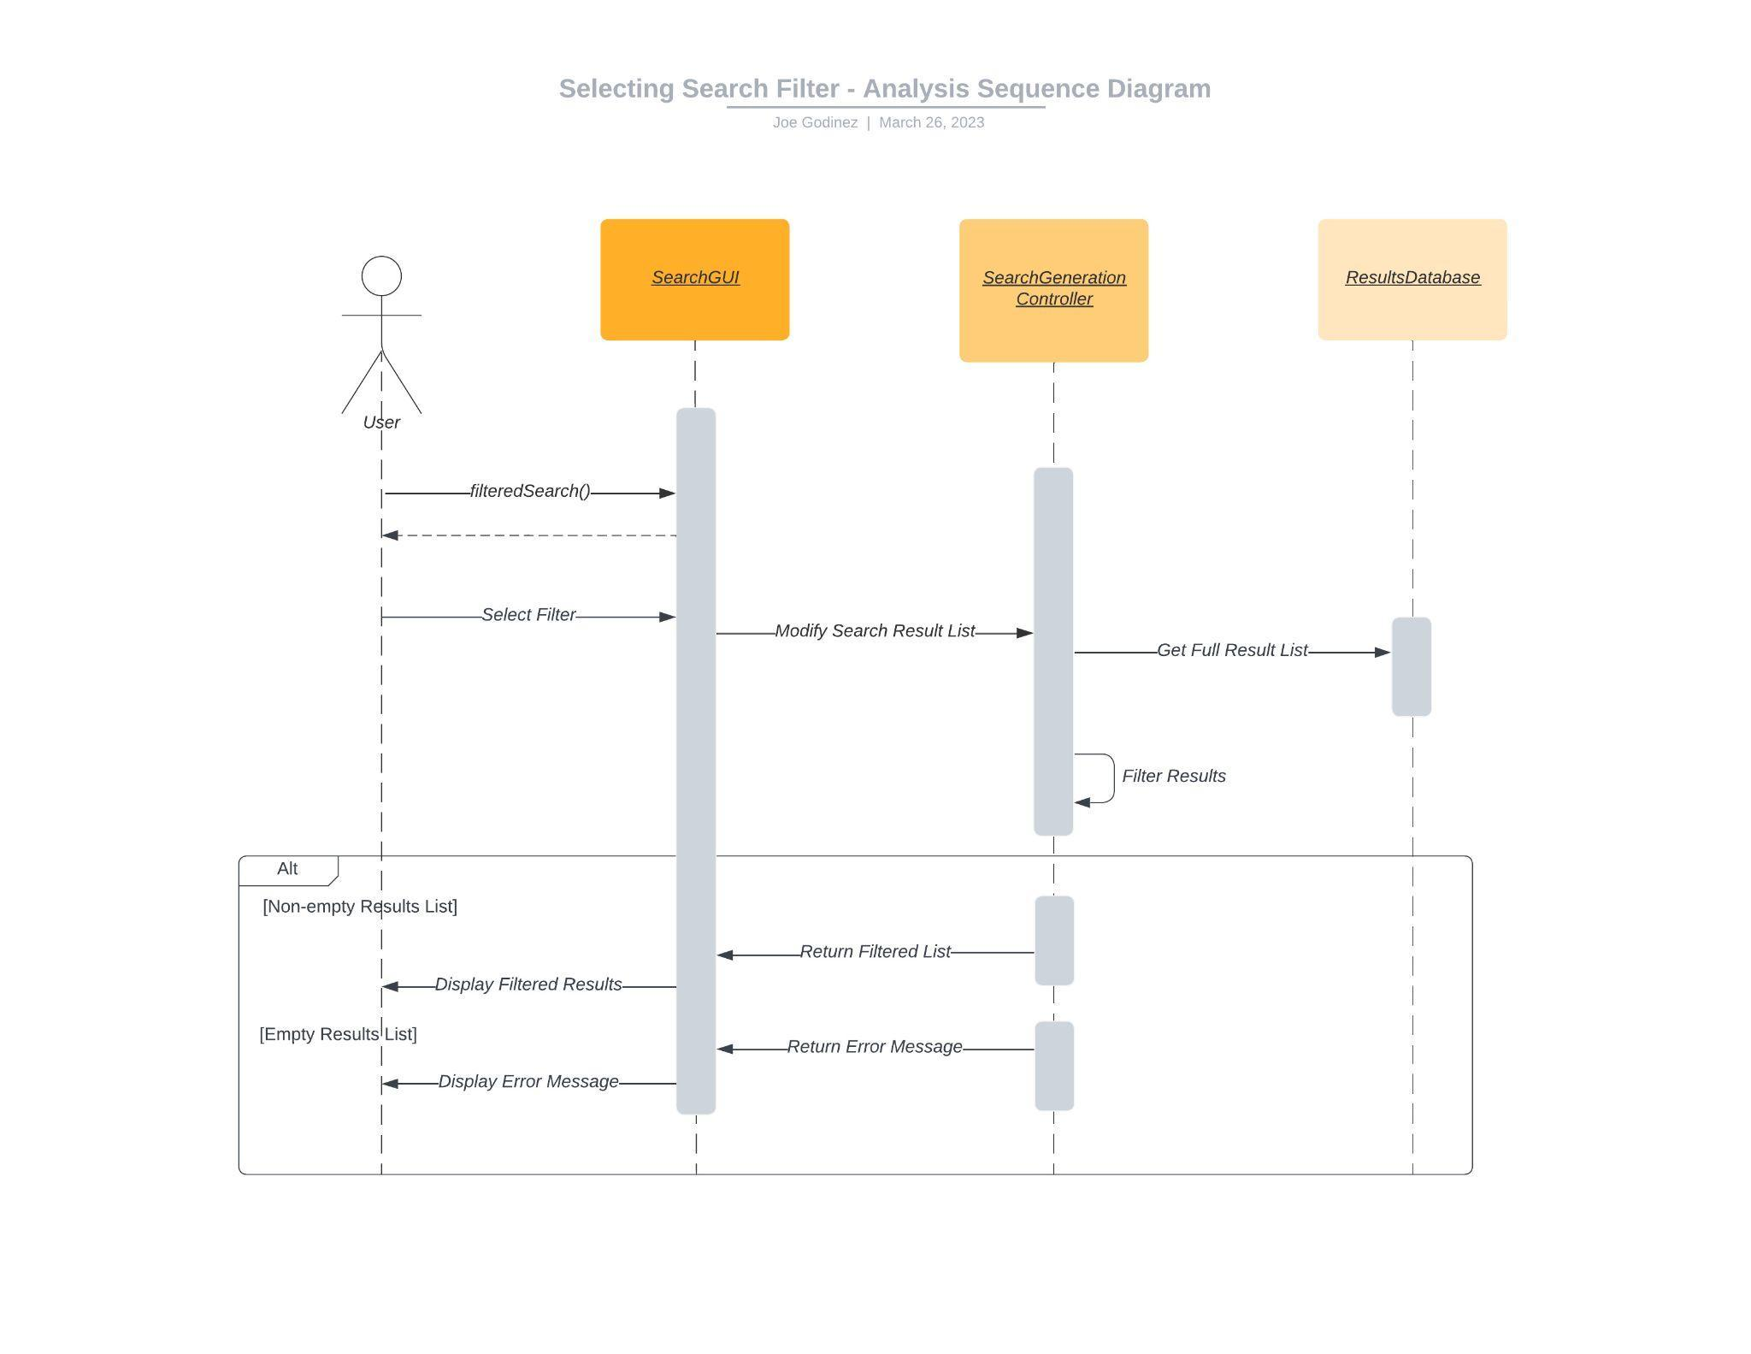

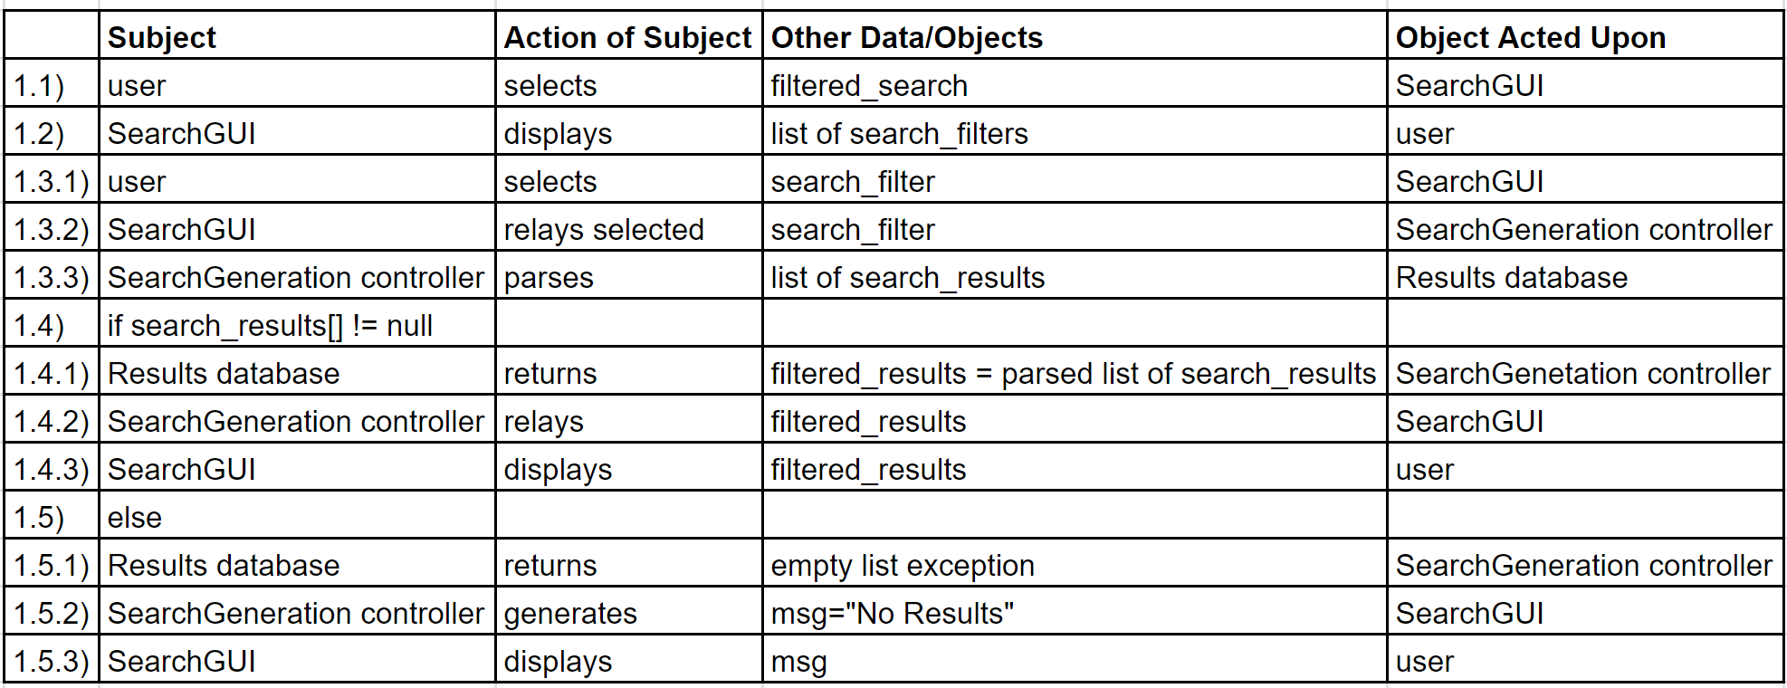

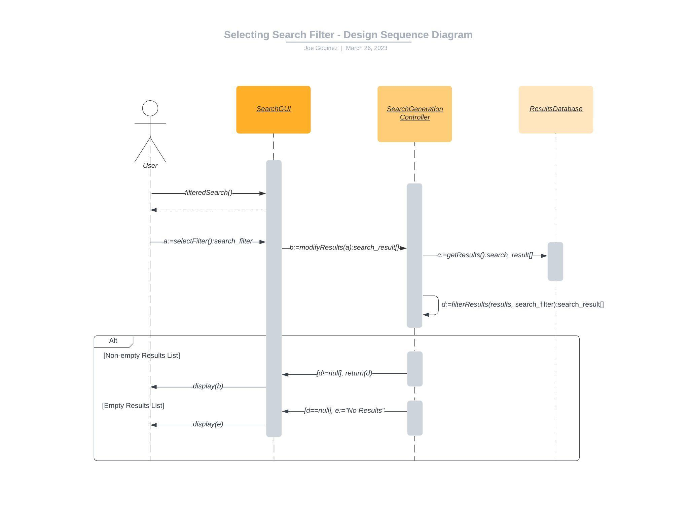

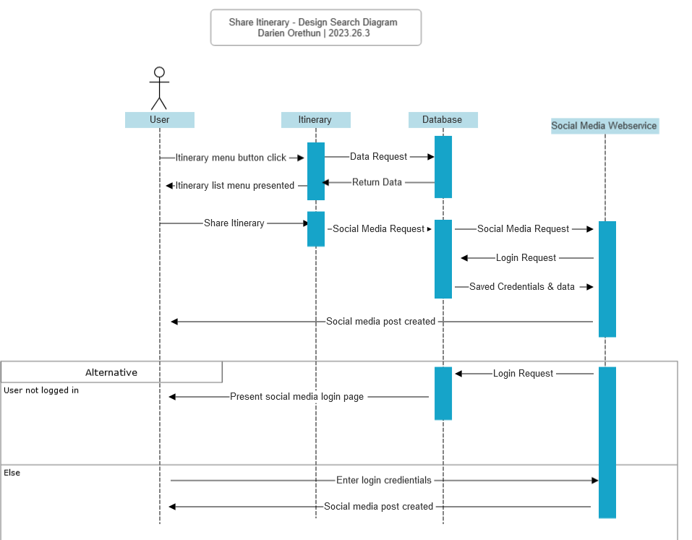

|  | Subject | Action | Other Data/Objects | Object Acted Upon |
| --- | --- | --- | --- | --- |
| 1 | User | Selects |  | Itinerary_Controller |
| 1.1 | Itinerary_Controller | Parses |  | Database |
| 1.2 | Database | Returns | Event_list | Itinerary_Controller |
| 1.3 | Itinerary_Controller | Displays |  | Itinerary_Controller |
| 2 | User | Selects |  | Itinerary_Controller |
| 2.1 | Database | Parses |  | Socialmedia_webservice |
| 2.2 | Socialmedia_webservice | Parses |  | Database |
| 2.3 | Database | Parses | Login_Info,Event_data | Socialmedia_webservice |
| 2.4 | Socialmedia_webservice | Displays | msg="Posted Successfully" | User |
| 3 | else |  |  |  |
| 3.1 | Socialmedia_webservice | Displays | Login_Request | User |
| 3.2 | User | Returns | Login_Info | Socialmedia_webservice |
| 3.3 | Socialmedia_webservice | Displays | msg="Posted Successfully" | User |

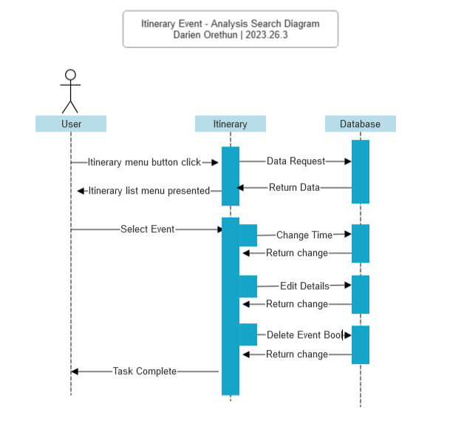

|  | Subject | Action | Other Data/Objects | Object Acted Upon |
| --- | --- | --- | --- | --- |
| 1 | User | Selects |  | Itinerary_Controller |
| 1.2 | Itinerary_Controller | Parses |  | Database |
| 1.3 | Database | Returns | Event_list | Itinerary_Controller |
| 2 | User | Selects | Event_Info | Itinerary_Controller |
|  | Itinerary_Controller | Parses | Event_info_Time | Database |
|  | Database | Parses | Event_info_Time | Itinerary_Controller |
|  | Itinerary_Controller | Parses | Event_info_Info | Database |
|  | Database | Parses | Event_info_Info | Itinerary_Controller |
|  | Itinerary_Controller | Parses | Event_info_Delbool | Database |
|  | Database | Parses | Event_info_Delbool | Itinerary_Controller |
|  | Itinerary_Controller | Returns | msg="Event Updated" | User |

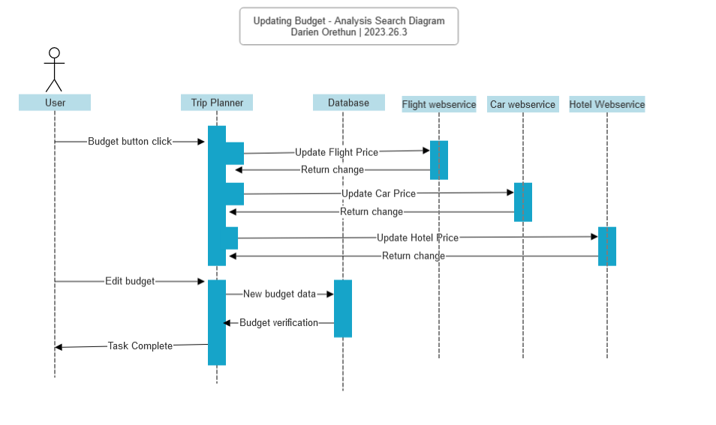

|  | Subject | Action | Other Data/Objects | Object Acted Upon |
| --- | --- | --- | --- | --- |
| 1 | User | Select |  | TripPlanner_controller |
| 1.1 | TripPlanner_controller | Parses | Flight_cost | flight_webservice |
| 1.2 | Flight_webservice | Parses | Flight_cost | TripPlanner_controller |
| 1.3 | TripPlanner_controller | Parses | Car_cost | Car_webservice |
| 1.4 | carwebservice | parses | Car_cost | TripPlanner_controller |
| 1.5 | TripPlanner_controller | Parses | Hotel_cost | Hotel_webservice |
| 1.6 | Hotel_webservice | Parses | Hotel_cost | TripPlanner_controller |
| 2 | User | Select | Trip_budget_info | TripPlanner_controller |
| 2.1 | tripPlanner_controller | parses | Trip_budget_info | database |
| 2.2 | database | parses | Trip_budget_info | TripPlanner_controller |
| 2.3 | tripPlanner_controller | displays | msg = budget_info_balance | user |

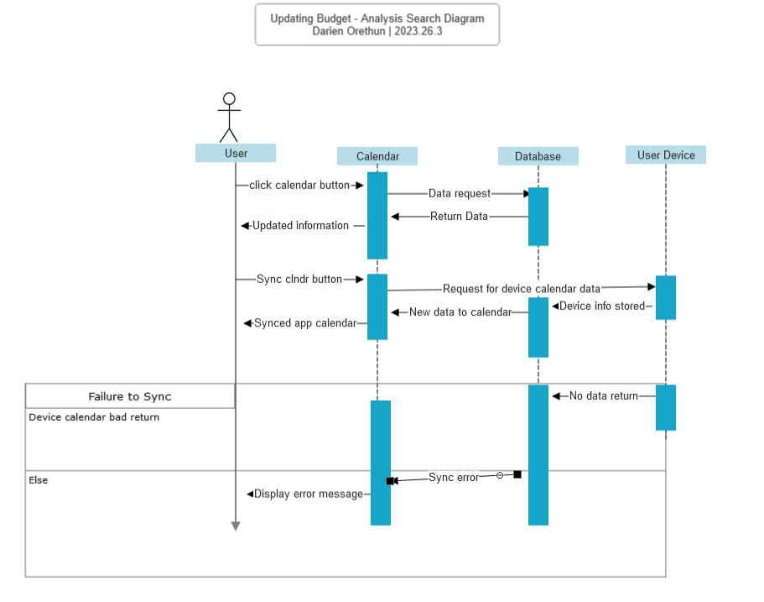

|  | Subject | Action | Other Data/Objects | Object Acted Upon |
| --- | --- | --- | --- | --- |
| 1 | User | Select |  | Calendar_controller |
| 1.1 | Calendar_controller | Parses | Calendar_list | Database |
| 1.2 | Database | Parses | Calendar_list | Calendar_controller |
| 1.3 | Calendar_controller | Displays | Calendar_list | user |
| 2 | User | Select | Sync_calendar | calendar_controller |
| 2.1 | calendar_controller | parses |  | userDevice_system |
| 2.2 | userDevice_system | parses | device_calendar_list | database |
| 2.3 | database | parses | device_calendar_list | calendar_controller |
| 2.4 | calendar_controller | Displays | msg="Calendar Synced" | user |
| 3 | else |  |  |  |
| 3.1 | userDevice_system | parses |  | calendar_controller |
| 3.2 | calendar_controller | Displays | msg="Sync Error" | User |